**PW Assignment**

**Question 1: Design an E-commerce system. Which includes the following set of features.**

**Sign Up**

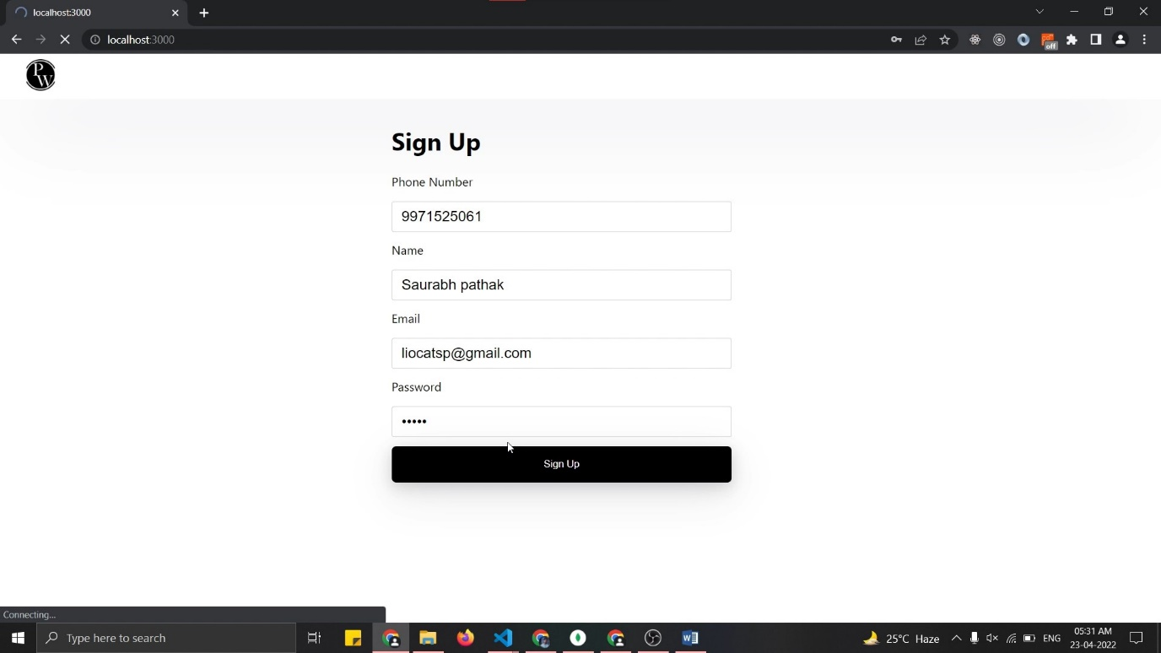

**Product List**

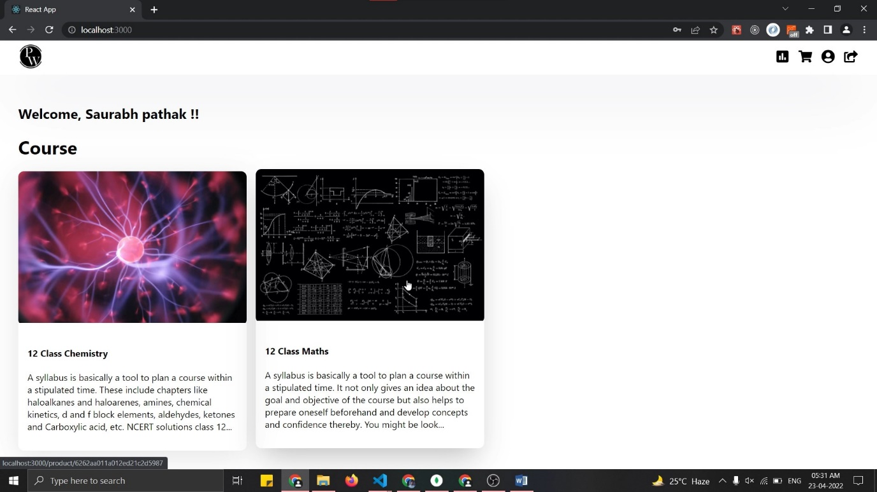

**Product Details**

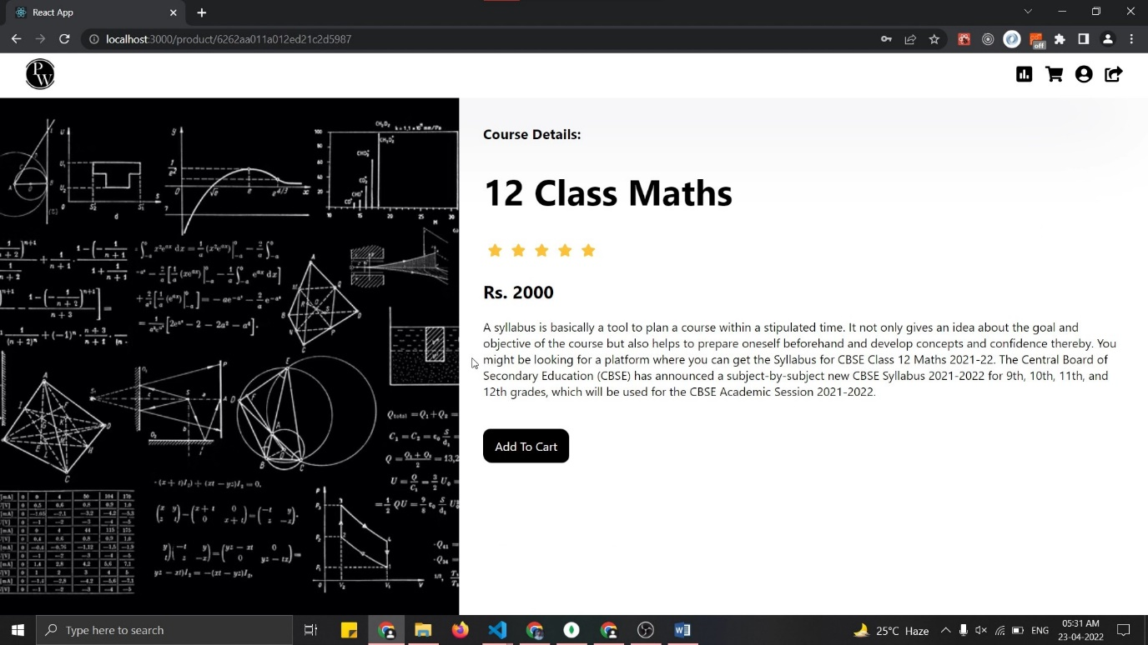

**Shopping Cart**

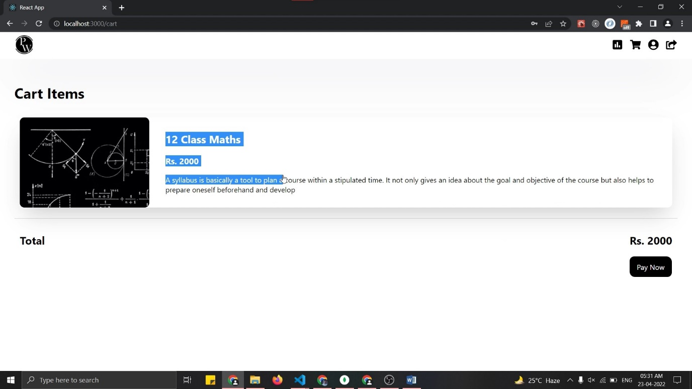

**Question 2: polling system**

1. **Create Poll**

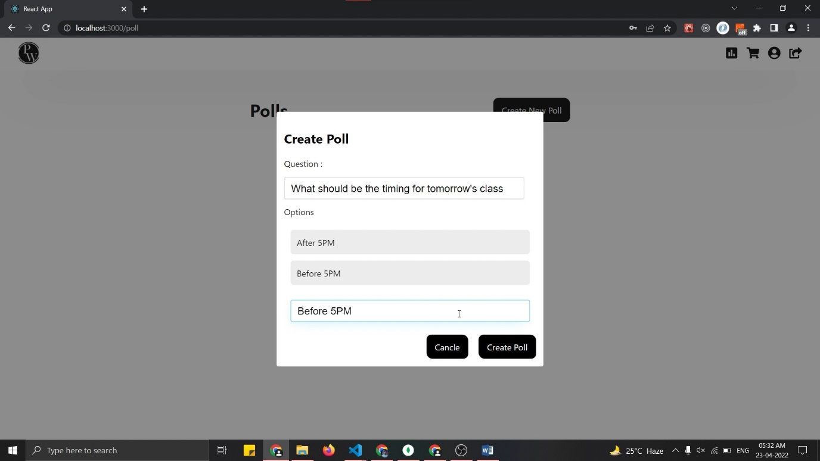

1. **Add Respones**

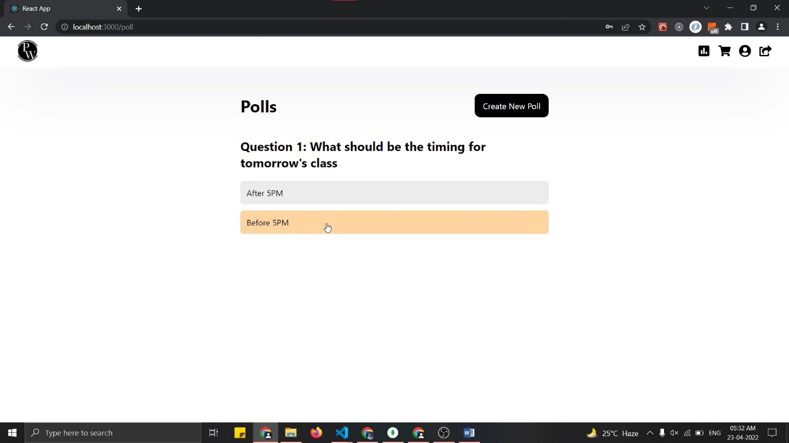

1. **Poll view after 2 responses**

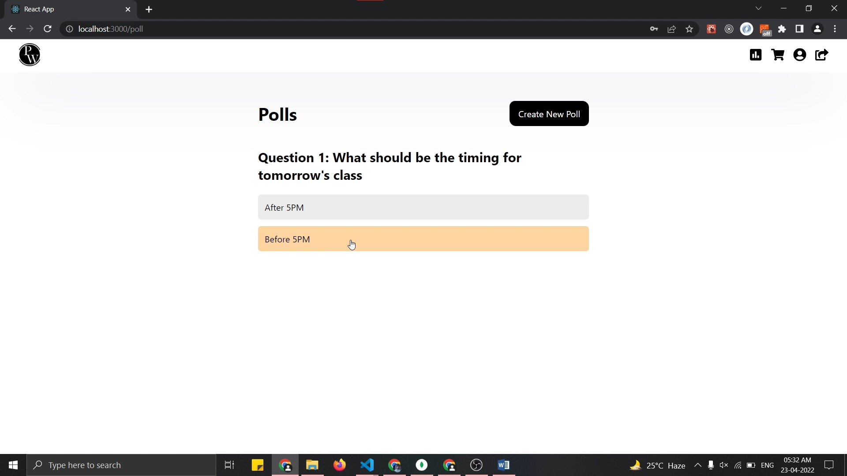

1. **Poll view after 3 responses**

